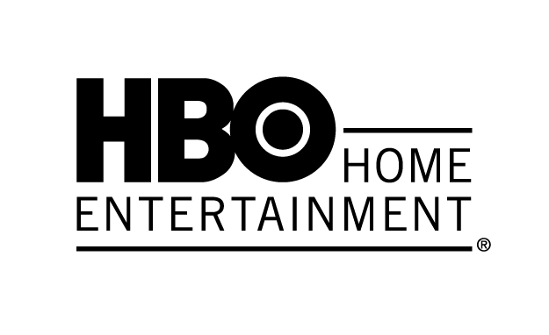
“A wondrous infusion of energy, twists and scares.” – Boston Herald

True Blood®: The Complete Sixth Season

Available on Blu-ray™ with Digital Copy, DVD & Digital HD June 3, 2014
Loaded with Exclusive Bonus Content and Timed to Premiere of the Final Season

Toronto, ON, May 29, 2014 – Vampire Bill is rebirthed as a powerful ancient deity, Louisiana Governor Truman Burrell declares open season on all vampires and Sookie Stackhouse finds herself sidelined by a mysterious stranger with a hidden agenda. True Blood shows no signs of slowing down in its sixth season. The sexy, scary, wildly entertaining series from Academy Award®-and-Emmy®-winner Alan Ball is packed with “suspense, surprises and crackling dialogue: True Blood is pumping strong.” (Boston Herald) True Blood: The Complete Sixth Season will be available on Blu-ray with Digital Copy ($99.99), DVD ($74.98) and Digital HD on June 3, 2014, just in time for fans to catch up before the final season makes its HBO debut this summer. Both sets include the full 10-episode season, along with extensive bonus materials including behind-the-scenes interviews and never-before-seen content.

Season six introduces several exciting new storylines that threaten what little sense of normalcy remains in Bon Temps: The Authority is in flames, and Tru Blood is in short supply. As Bill comes to terms with his newfound powers after emerging reincarnated from a pool of blood, Louisiana’s governor has declared war, replete with novel anti-vamp weapons and a high-tech internment camp established to wipe out the vampire race forever. Meanwhile, Sookie and Jason must steel themselves for an encounter with their parents’ killer: the mysterious and ancient Warlow.

Bonus Material
Packed with extensive audio commentaries and features that take fans even deeper into their favourite storylines and relationships, the sixth season’s bonus material offers an array of exciting content to keep even the most hardcore “Truebies” sated.

Blu-ray Features (along with all DVD extras):
- Vamp Camp Files – get an inside look at the secret trove of documents detailing the effort to eradicate vampires via the institution known as “Vamp Camp.”
- True Blood Lines – uncover secrets from relationships past and present in this engaging fully interactive guide and archive.
DVD Features:
- Inside the Episodes (10 Clips) – get the backstories on each episode with revealing interviews from the show writers.
- Audio Commentaries – five commentaries with cast and crew including executive producer Brian Buckner, Stephen Moyer, Carrie Preston, Amelia Rose Blaire and more!
- Previews & Recaps
-more-

True Blood: The Complete Sixth Season…Page 2

True Blood: The Complete Sixth Season
Blu-ray with Digital Copy, DVD & Digital HD
Street Date: June 3, 2014
Order Date: April 29, 2014
Rating: TV-MA
Runtime: Approx. 600 minutes (excluding bonus features)
Price: $99.99 Blu-ray with Digital Copy (4 BD discs Digital Copy)
Price: $74.98 DVD (4 discs)

True Blood cast members include Anna Paquin as waitress and part-faerie Sookie Stackhouse; Stephen Moyer as vampire Bill Compton; Alexander Skarsgård as vampire Eric Northman; Ryan Kwanten as Sookie’s trouble-prone brother, Jason Stackhouse; Rutina Wesley as Pam’s newly-turned progeny, Tara Thornton; Sam Trammell as Sookie’s shape-shifting boss, Sam Merlotte; Nelsan Ellis as Tara’s clairvoyant sharp-tongued cousin, Lafayette Reynolds; Carrie Preston as Arlene Bellefleur, a Merlotte’s waitress; Todd Lowe as Terry Bellefleur; Chris Bauer as Terry’s cousin, sheriff Andy Bellefleur; Deborah Ann Woll as Jessica Hamby, Bill’s vampire progeny; Kristin Bauer van Straten as Pam, Eric’s vampire progeny and business partner; Lauren Bowles as Holly, a Merlotte’s waitress; Joe Manganiello as werewolf Alcide Herveaux; Michael McMillian as vampire Steve Newlin; Lucy Griffiths as Nora, a former chancellor of the Vampire Authority; Kelly Overton as werewolf Rikki; and Anna Camp as anti-vampire crusader Sarah Newlin.

New cast members for season six include: Arliss Howard as Louisiana Governor Truman Burrell; Rob Kazinsky as Ben, a stranger with faerie ties; Rutger Hauer as Niall, a faerie grandfather; Jurnee Smollett-Bell as Nicole, a pro-vampire activist; and Amelia Rose Blaire as Truman Burrell’s daughter, Willa.

About HBO Home Entertainment®
HBO Home Entertainment develops, distributes and markets an extensive array of critically-acclaimed and groundbreaking programs in three formats: Blu-ray, DVD, and digital throughout the world. Releases include the global hits Game of Thrones®, True Blood® and Girls®, favourites such as The Sopranos®, Sex and the City® and Entourage®, and multiple Emmy Award-winning mini-series The Pacific® and Band of Brothers®. The company’s catalog contains hundreds of titles including the Peabody Award-winning children’s program Classical Baby, provocative programs from HBO Documentary Films including The Weight of the Nation, innovative movies from HBO Films including Game Change and Behind the Candelabra, and comedy specials featuring stand-up performers like George Lopez and Ricky Gervais. Launched in 1984, HBO Home Entertainment has offices in New York, London and Toronto and the company’s releases are sold in over 80 territories around the world.

Creative assets are located at: www.lexpr.com/media_kit/true-blood-s6/

For more information, please contact:
Alistair Kyte, LexPR - (416) 542-9140 x3362 / akyte@lexpr.com
Darren Bigras, LexPR - (416) 542-9140 x3369 / dbigras@lexpr.com

